Research-in-Progress

# Structure

The proposal serves to illustrate the most important aspects of your thesis:

1. What do you want to investigate in your work and which results do you expect?

*Aim of your research – WHAT?*

1. How do you want to achieve the aims of your work?

*Design of your research – HOW?*

Your proposal is an important first step for your thesis. The proposal helps you to understand your own research topic and to express your idea and working method.

The thesis proposal should implement following structure:

Working title of your thesis

1. Introduction

*What is the topic and why should we care?  
What question your research intends to answer?*

1. Theoretical background

*What are the things we need to know form research regarding the topic?*

1. Initial research model (empirical research)  
   *What are your theoretical considerations (so far)?  
   OR*Initial specification of the artifact (design science research)  
   *What are (assumed) meta-requirements on the artifact based on theory?*
2. Research design

*How do you plan to answer the research question?*

1. Expected contributions

*What do you expect to contribute to the body of knowledge?*

Please add following additions to the appendix of your initial proposal (Appendix A)

1. Schedule until delivery of your thesis

*What do you need to do until when?*

Writing your proposal and already thinking about all these aspects is a challenge and needs a lot of reading, thinking and hard work. The good part is, that once you have written and discussed your proposal with your supervisor, the road for your thesis is paved and you can start work straight according to plan.

# Formal requirements

## Indexes

Tables of contents and lists of figures/tables are not required.

## Formatting

You should format your paper exactly like this document. The template file contains specially formatted styles that are designed to reduce the work in formatting your paper and increase comparability.

## Length

The extended proposal should be 5 pages long, excluding the references and the appendix.

## Header and Footer

Please modify the header from page 2 on (running title) and the footer (page 1 as well as page 2 and following) accordingly.

## Sections

Use the title style for your working title, the heading styles for sections, and subsections.   
Please do not go any further into another layer/level.

## Figures

Place figures and tables close to the relevant text (or where they are referenced in the text).

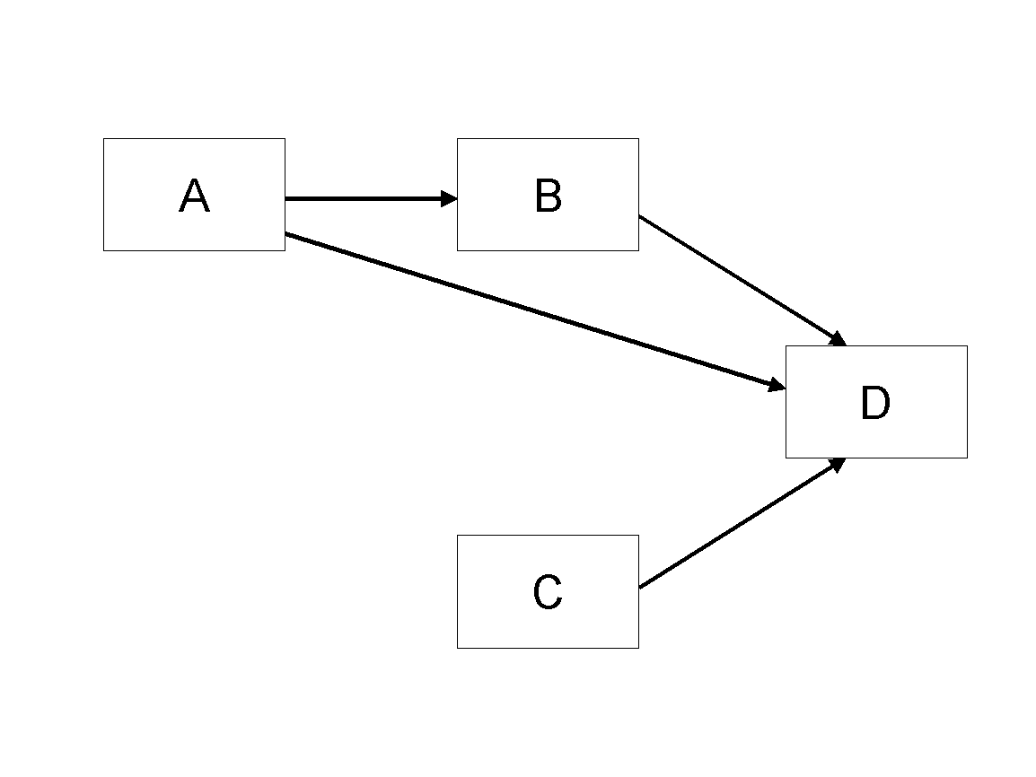

Figure 1. Model

## Tables

Inserting a table in the text can work well. You may want to adjust the vertical spacing of the text in the tables. (In Word, use Format | Paragraph… and then the Line and Page Breaks tab. Generally, text in each field of a table will look better if it has equal amounts of spacing above and below it, as in Table 1.)

|  |  |  |
| --- | --- | --- |
|  | **Treatment 1** | **Treatment 2** |
| **Setting A** | 125 | 95 |
| **Setting B** | 85 | 102 |
| **Setting C** | 98 | 85 |

Table 1. A Very Nice Table

## References and Citations

References are to be formatted using the *APA 7th* style. References must be complete, i.e., include, as appropriate, volume, number, month, publisher, city and state, editors, last name & initials of all authors, page numbers, etc.

Your references should comprise only published materials accessible to the public. Proprietary information may not be cited.

References should be ordered in alphabetic order.

# References

Haki, Kazem; Beese, Jannis; Aier, Stephan; and Winter, Robert. 2020. "The Evolution of Information Systems Architecture: An Agent-Based Simulation Model," *MIS Quarterly*, (44: 1) pp.155-184.

# Appendix A: Schedule

Add schedule here.

# Appendix: Declaration on the use of GenAI tools

[If you have not used GenAI keep the following sentence and delete the rest of the text.]

In the preparation of this paper, I have not used systems based on generative artificial intelligence (GenAI).

[If you have used GenAI complete the following declaration.]

In the preparation of this paper, I have used following tools based on generative artificial intelligence (GenAI):

1. ChatGPT
2. DeeplWrite

[List other systems if others where used.]

I further declare that

* I have labeled the content taken from the GenAI tools listed above with my details in the table below,
* I have verified that the content generated by the above-mentioned GenAI tools and adapted by me is factually correct,
* I am aware that, as the author of this work, I am responsible for the information and the statements made in it, and
* I am aware that violating the disclosure of the use of generative AI in my work is a deception and leads to an evaluation with an insufficient grade.

I have used the above-mentioned AI systems as indicated below.

|  |  |  |
| --- | --- | --- |
| Areas of contribution | AI tool(s) used | Description of the manner of use and compliance with good scientific practice (if applicable, please indicate the section of the paper) |
| Development and conception of the research project | None |  |
| Identification of literature |  |  |
| Synthesizing of literature |  |  |
| Structuring the text |  |  |
| Formulation of text |  |  |
| Revision of text | 2 |  |
| Creation of visualizations |  |  |
| Further contributions |  |  |