Your Title

Team
Please add the name of your team to the headline and complement the table below:
Surname & Name | Student ID | Study Program

Formal requirements

Formatting
You should format your paper exactly like this document. The template file contains specially formatted styles that are designed to reduce the work in formatting your final submission.
Delete comments.

Length
The paper should contain at least 6 pages text per person and must not exceed 10 pages per person (excluding references, and the appendices).

Header and Footer
Please modify the header from page 2 on (title) and the footer (name and student number) accordingly.

Sections
Use the heading styles for sections, subsections, and sub-subsections.

Sub-subsections
Please do not go any further into another layer/level.

Figures
Place figures and tables close to the relevant text (or where they are referenced in the text).
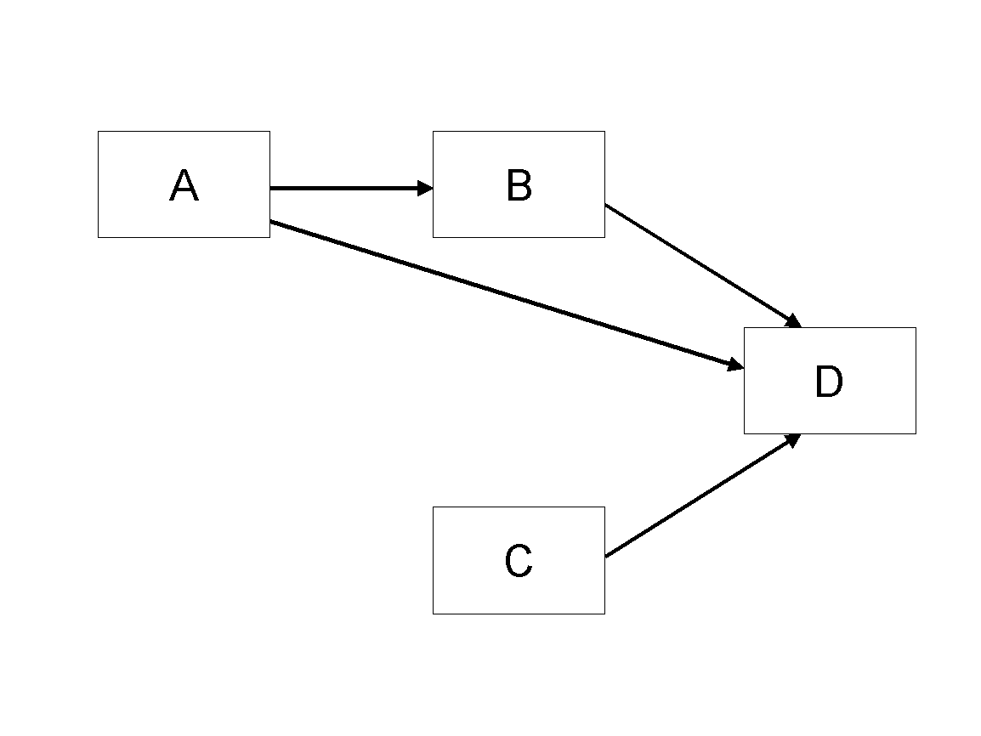
Figure 1. Modified Research Model

Tables
Inserting a table in the text can work well. You may want to adjust the vertical spacing of the text in the tables. (In Word, use Format | Paragraph… and then the Line and Page Breaks tab. Generally, text in each field of a table will look better if it has equal amounts of spacing above and below it, as in Table 1.)
 | Treatment 1 | Treatment 2
Setting A | 125 | 95
Setting B | 85 | 102
Setting C | 98 | 85
Table 1. A Very Nice Table

References and Citations
References are to be formatted using the APA 7th edition style.
References must be complete, i.e., include, as appropriate, volume, number, month, publisher, city and state, editors, last name & initials of all authors, page numbers, etc.
Your references should comprise only published materials accessible to the public. Proprietary information may not be cited.
References should be ordered in alphabetic order.

Appendix

