Case Study Title

Formal requirements

Formatting
You should format your paper exactly like this document. The template file contains specially formatted styles that are designed to reduce the work in formatting your final submission.

Length
The paper should be at least 12 pages long and must not exceed 16 pages (each excluding the references and the appendix).

Header and Footer
Please modify the header from page 2 on (title) and the footer (name and student number) accordingly.

Sections
Use the heading styles for sections, subsections, and sub-subsections.

Sub-subsections
Please do not go any further into another layer/level.

Figures
Place figures and tables close to the relevant text (or where they are referenced in the text).
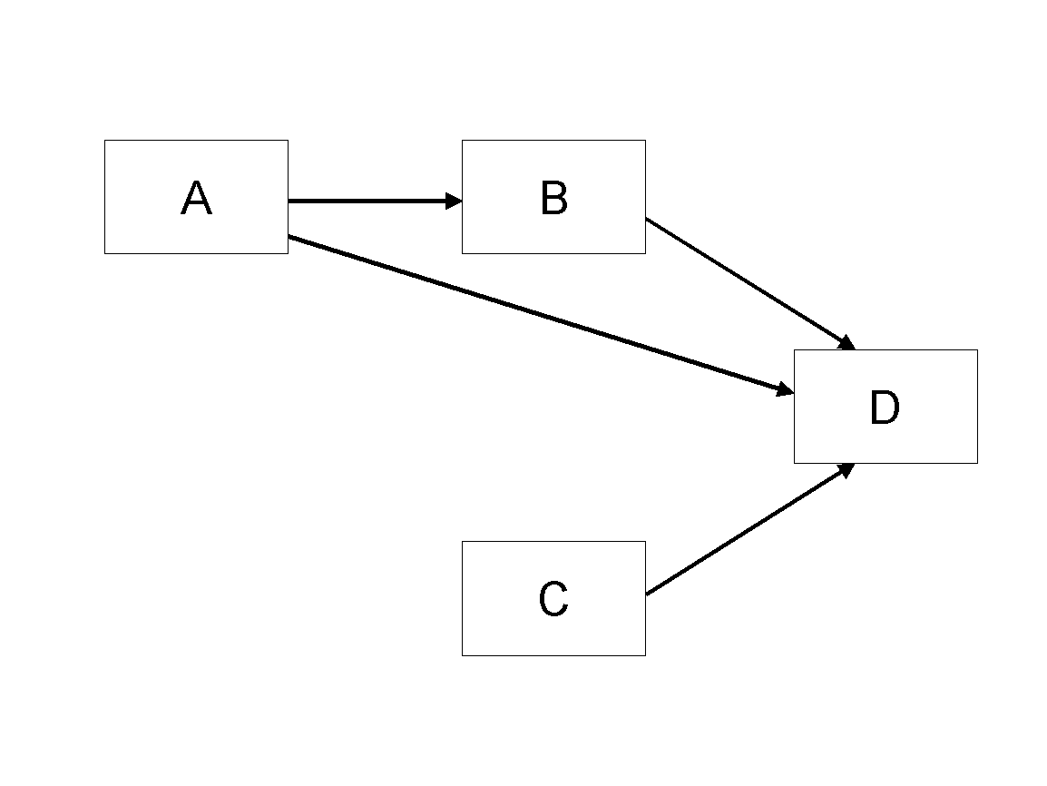
Figure 1. Modified Research Model

Tables
Inserting a table in the text can work well. You may want to adjust the vertical spacing of the text in the tables. (In Word, use Format | Paragraph… and then the Line and Page Breaks tab. Generally, text in each field of a table will look better if it has equal amounts of spacing above and below it, as in Table 1.)
 | Treatment 1 | Treatment 2
Setting A | 125 | 95
Setting B | 85 | 102
Setting C | 98 | 85
Table 1. A Very Nice Table

References and Citations
References are to be formatted using the new MIS Quarterly style (http://www.misq.org/manuscript-guidelines under MISQ References Format). References must be complete, i.e., include, as appropriate, volume, number, month, publisher, city and state, editors, last name & initials of all authors, page numbers, etc. If you use EndNote, be aware that different versions of the software change the styles, creating some inconsistencies. Please also be aware that the MIS Quarterly style provided by default in the EndNote X4 software (and all earlier versions) is for the old MIS Quarterly style. You may access the End Note Style here.
Your references should comprise only published materials accessible to the public. Proprietary information may not be cited.
References should be ordered in alphabetic order.

Appendix

