Theory

Structure
Your paper needs to cover following contents:
- Title (i.e., name of the theory)
- Concise description of the theory
including main dependent and independent constructs as well as a classification.
- Originating area and authors (if applicable)
- References to seminal articles
- Application of the theory in IS (examples incl. relevant findings)
In addition, you need to declare the use of GenAI tools.
Please use the template provided below (Appendix).

Formal requirements

Indexes
Tables of contents and lists of figures/tables are not required.

Formatting
You should format your paper exactly like this document. The template file contains specially formatted styles that are designed to reduce the work in formatting your paper and increase comparability.

Length
Seminar paper should be at least 1.500 words, but not exceed 2.000 words
(excluding tables, figures, and references)

Header and Footer
Please modify the header from page 2 on (running title) and the footer accordingly.

Sections
Use the title style for your title (i.e., name of the theory), the heading style 1 for sections and heading style 2 for subsections. Please do not go any further into another layer/level.

Sub-subsections
Please do not go any further into another layer/level.

Figures
Place figures and tables close to the relevant text (or where they are referenced in the text).
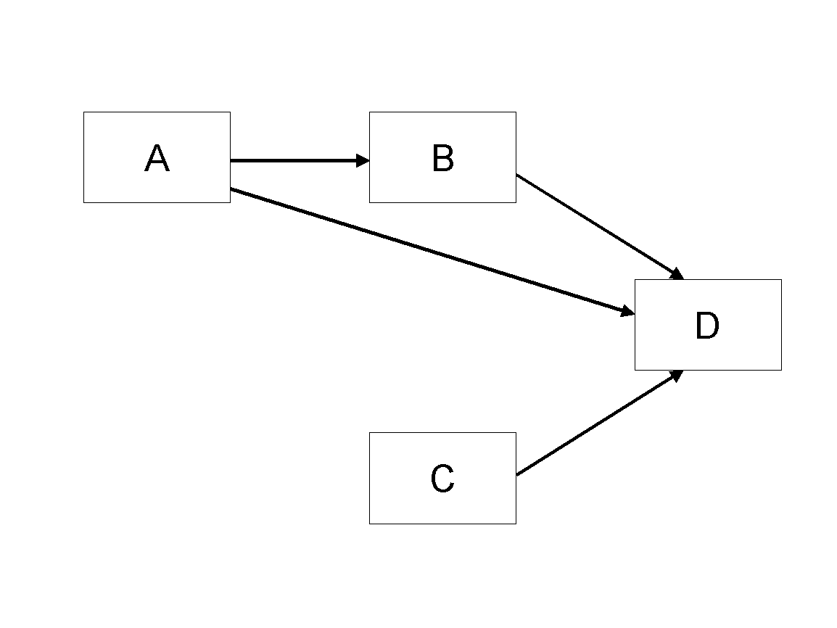
Figure 1. Model

Tables
Inserting a table in the text can work well. You may want to adjust the vertical spacing of the text in the tables. (In Word, use Format | Paragraph… and then the Line and Page Breaks tab. Generally, text in each field of a table will look better if it has equal amounts of spacing above and below it, as in Table 1.)
 | Treatment 1 | Treatment 2
Setting A | 125 | 95
Setting B | 85 | 102
Setting C | 98 | 85
Table 1. A Very Nice Table

References and Citations
References are to be formatted using the APA 7th style. References must be complete, i.e., include, as appropriate, volume, number, month, publisher, city and state, editors, last name & initials of all authors, page numbers, etc.
Your references should comprise only published materials accessible to the public. Proprietary information may not be cited.
References should be ordered in alphabetic order.

References
Haki, Kazem; Beese, Jannis; Aier, Stephan; and Winter, Robert. 2020. "The Evolution of Information Systems Architecture: An Agent-Based Simulation Model," MIS Quarterly, (44: 1) pp.155-184.

Appendix: Declaration on the use of GenAI tools
[If you have not used GenAI keep the following sentence and delete the rest of the text.]
In the preparation of this paper, I have not used systems based on generative artificial intelligence (GenAI).
[If you have used GenAI complete the following declaration.]
In the preparation of this paper, I have used following tools based on generative artificial intelligence (GenAI):
- ChatGPT
- DeeplWrite
[List other systems if others where used.]
I further declare that
- I have labeled the content taken from the GenAI tools listed above with my details in the table below,
- I have verified that the content generated by the above-mentioned GenAI tools and adapted by me is factually correct,
- I am aware that, as the author of this work, I am responsible for the information and the statements made in it, and
- I am aware that violating the disclosure of the use of generative AI in my work is a deception and leads to an evaluation with an insufficient grade.
I have used the above-mentioned AI systems as indicated below.
Areas of contribution | AI tool(s) used | Description of the manner of use and compliance with good scientific practice (if applicable, please indicate the section of the paper)
Development and conception of the research project | None
Identification of literature
Synthesizing of literature
Structuring the text
Formulation of text
Revision of text | 2
Creation of visualizations
Further contributions

